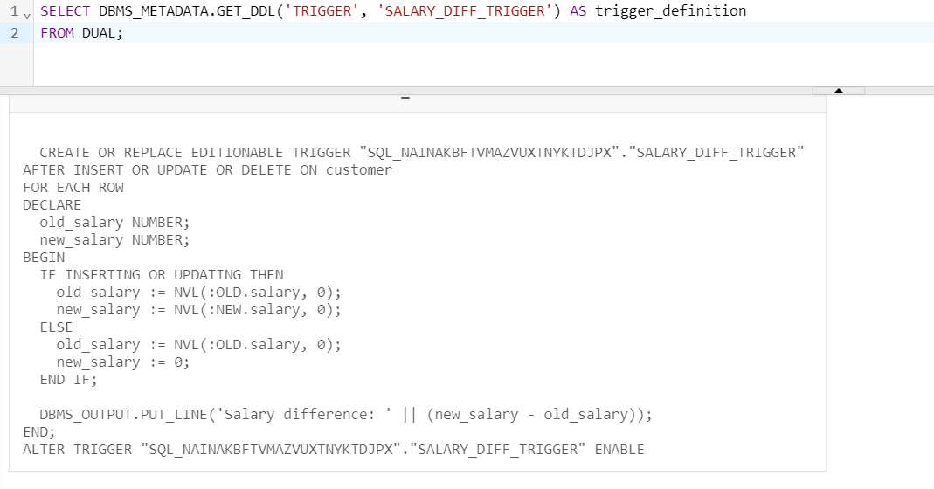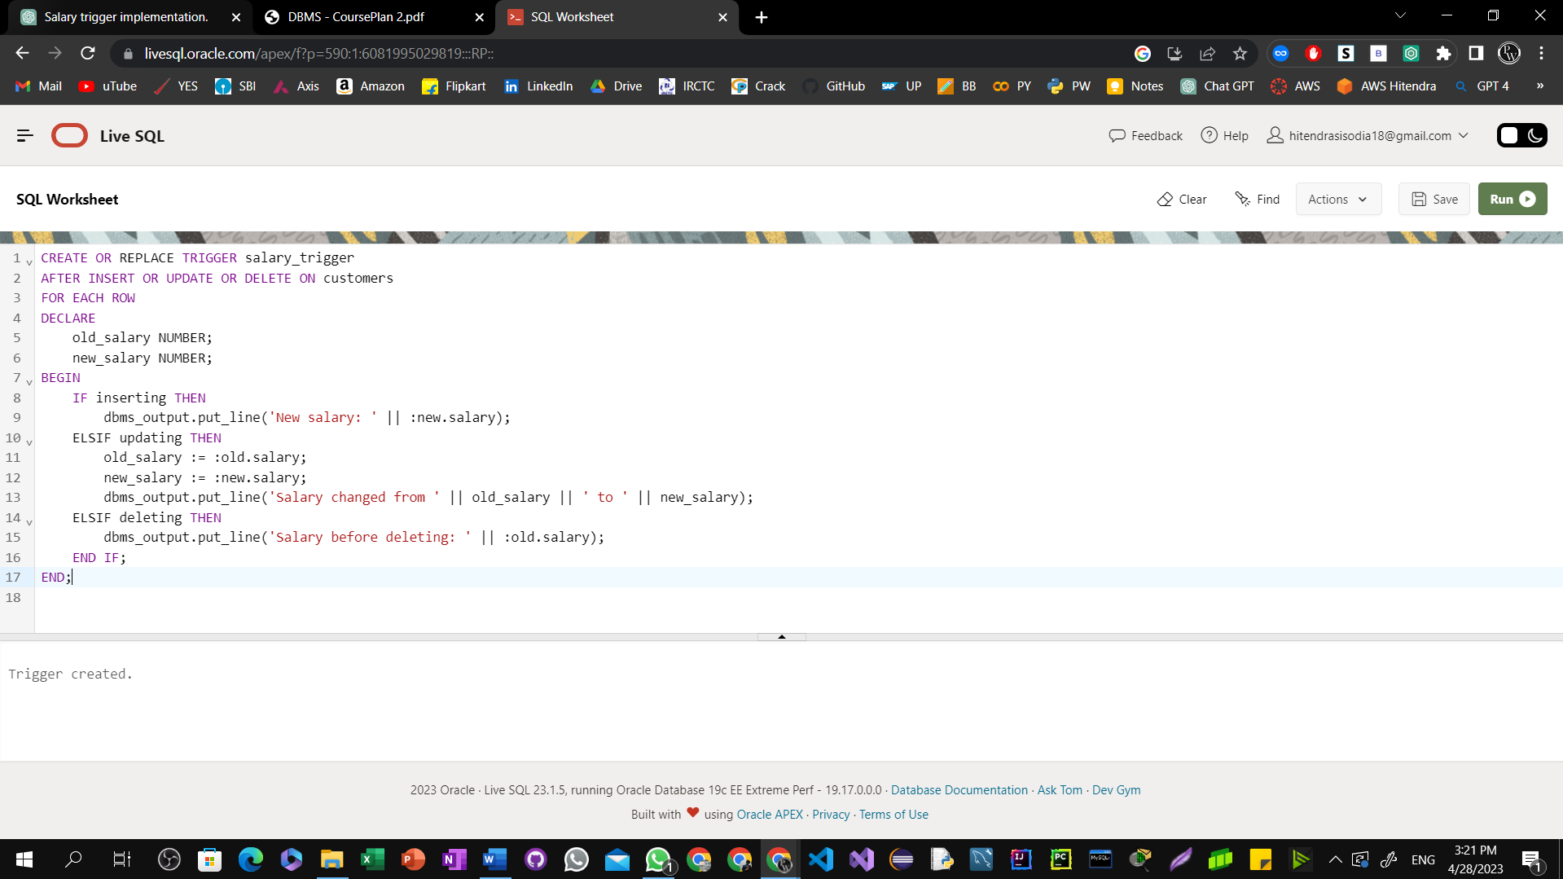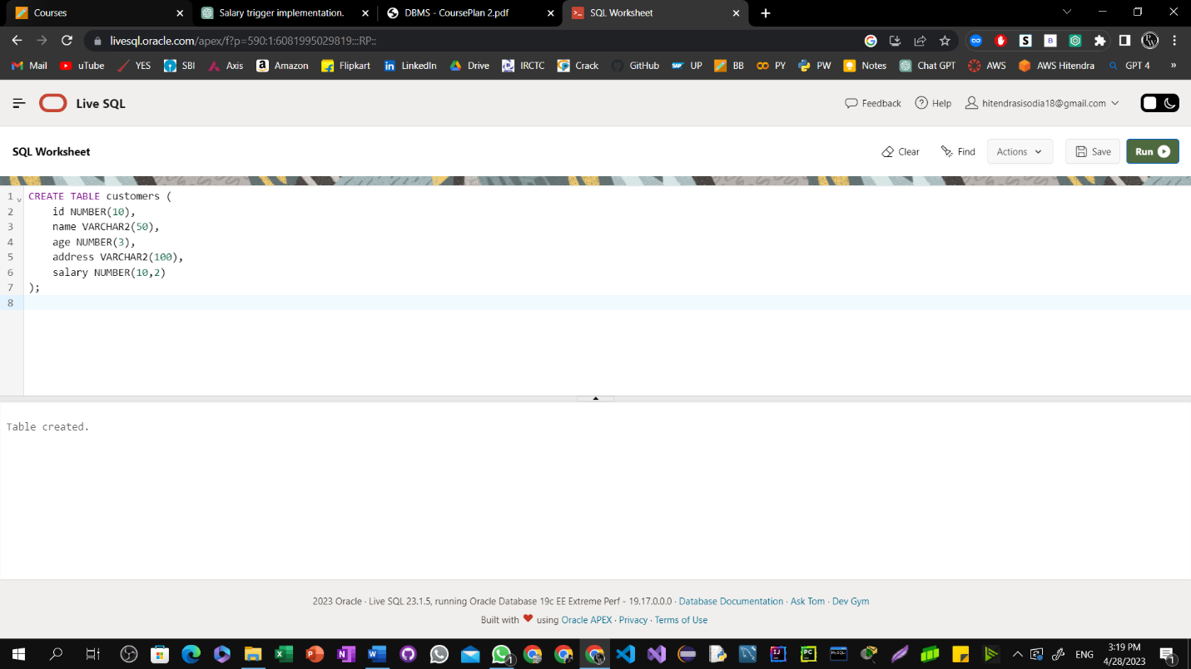Ques1: Create a row level trigger for the customers table that would fire for INSERT or UPDATE or DELETE operations performed on the CUSTOMERS table. This trigger will display the salary difference between the old values and new values.